**第13次课 深度语义理解（Transformer） 副本**

在解决seq2seq问题中，使用到了attention结构

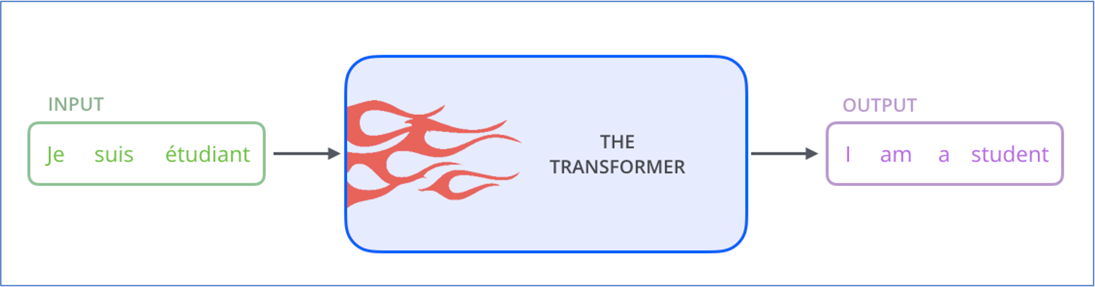

Transformer与CNN的关系：

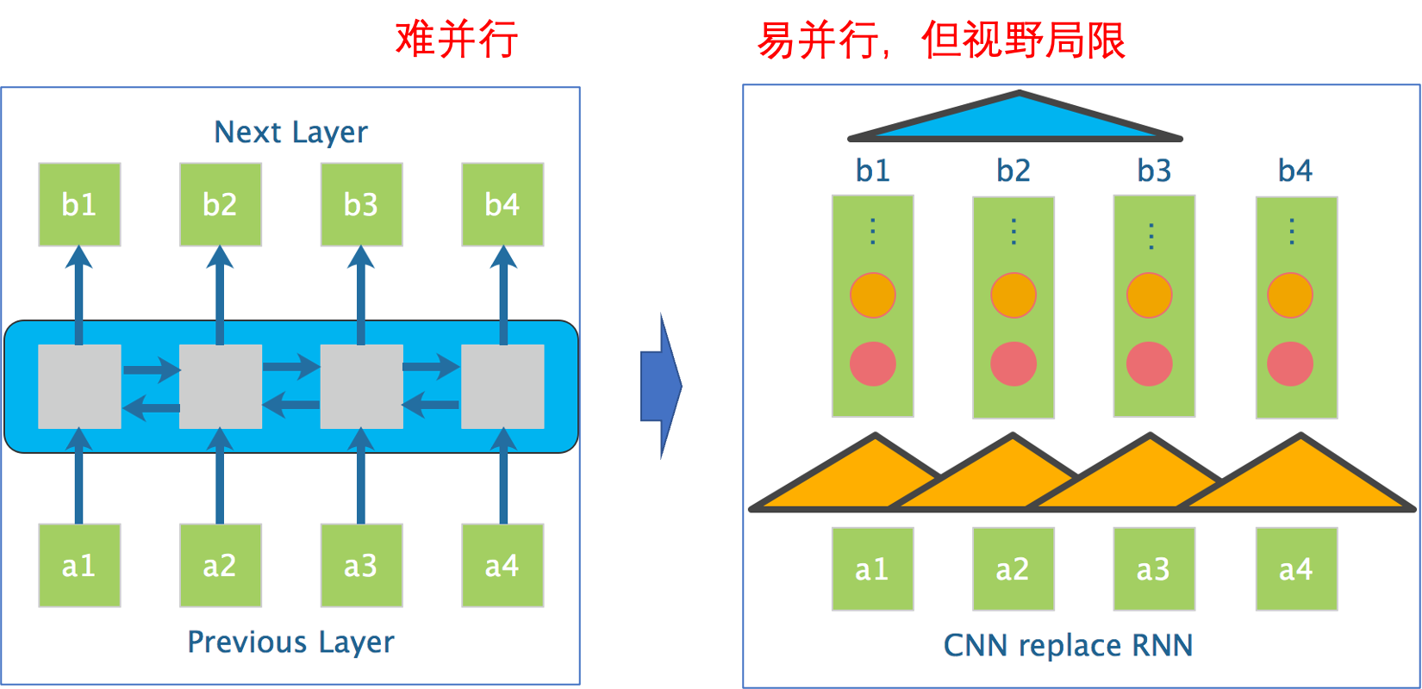

Transformer与RNN的关系：

讲self-attention替代RNN，可以解决一切问题

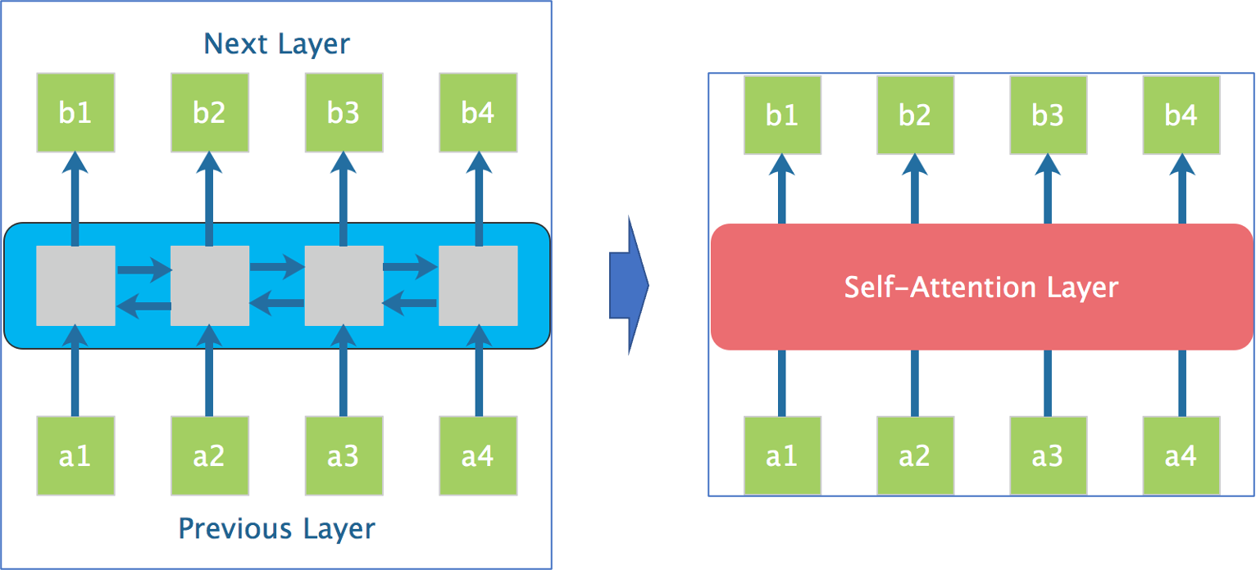

**一、Attention is all your need**

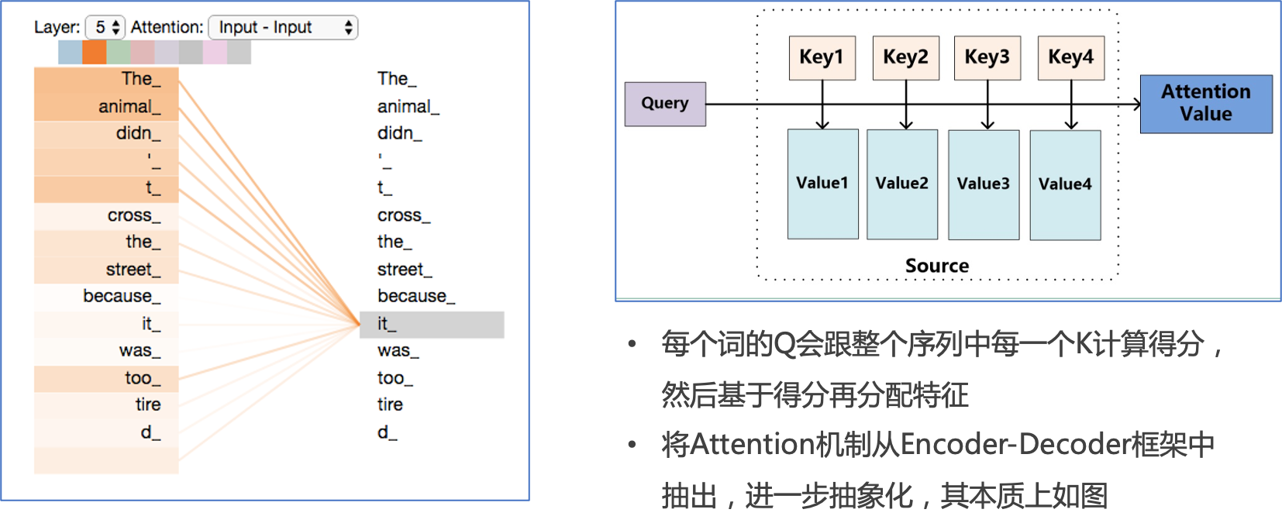

|  |  |
| --- | --- |
|  | Key和Value是对应的，Query看做是target中的数据，计算Attention流程：   * 计算Query和Source中各个Key的相似性，得到每个Key对应的Value的权重系数 * 利用计算出来的权重系数对各个Value的值加权求和，就得到了Attention的结果     Attention本质是一种对齐方法 |

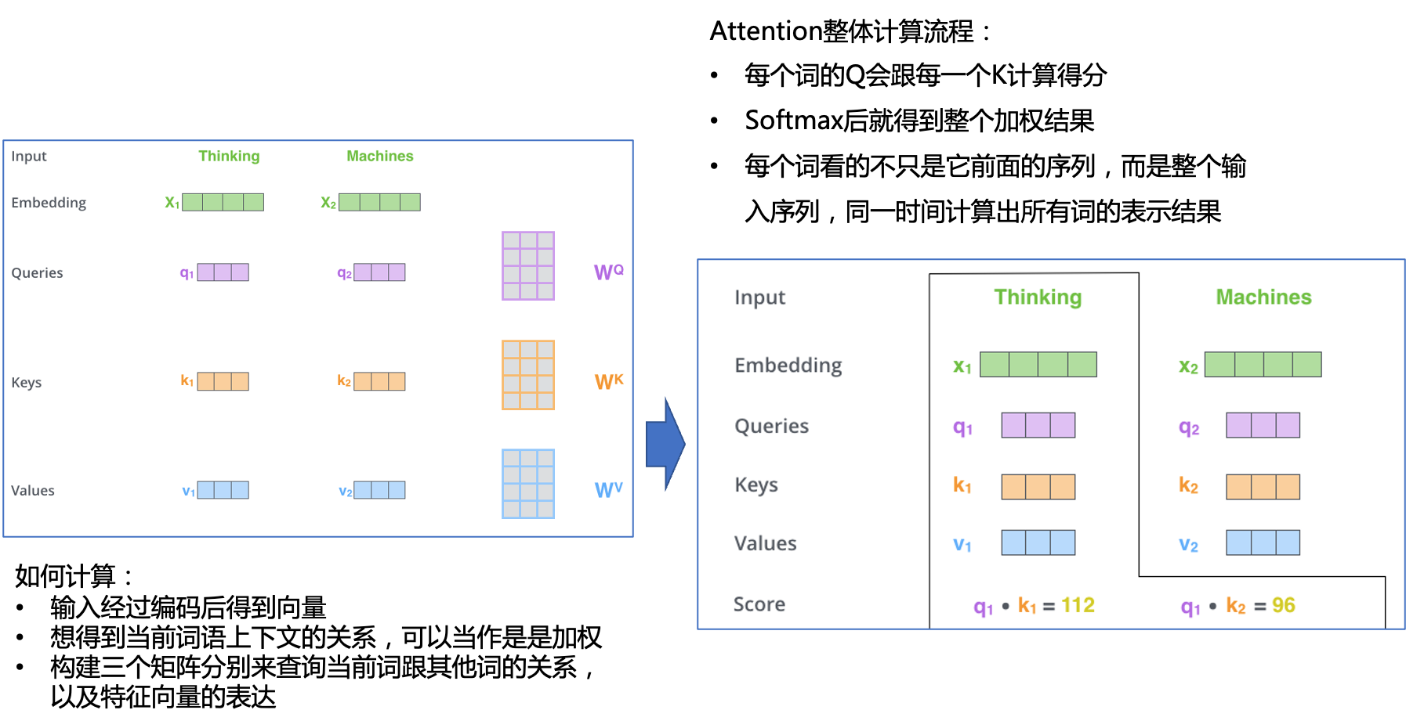

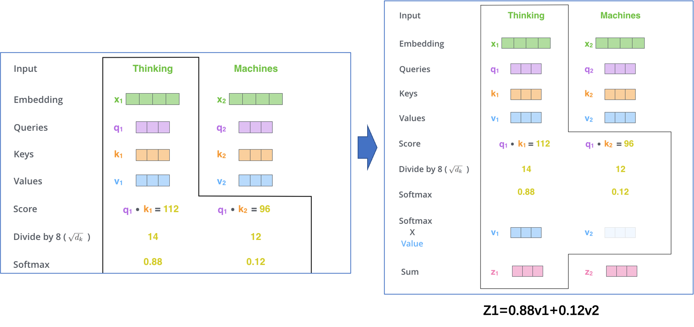

关于Self-Attention的另外一种形式理解：

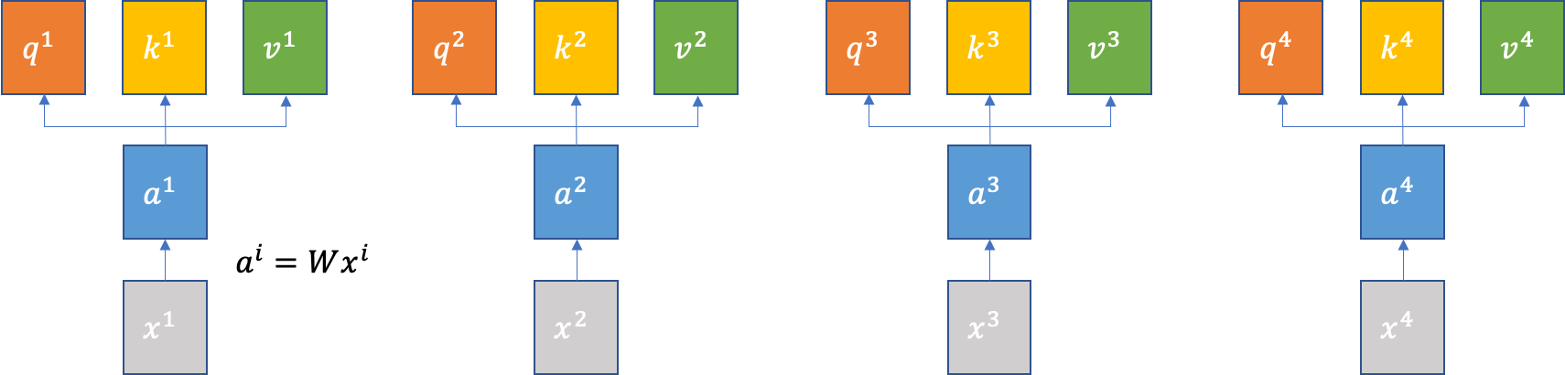

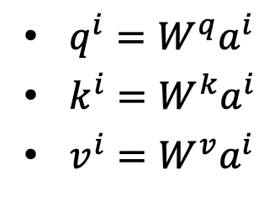

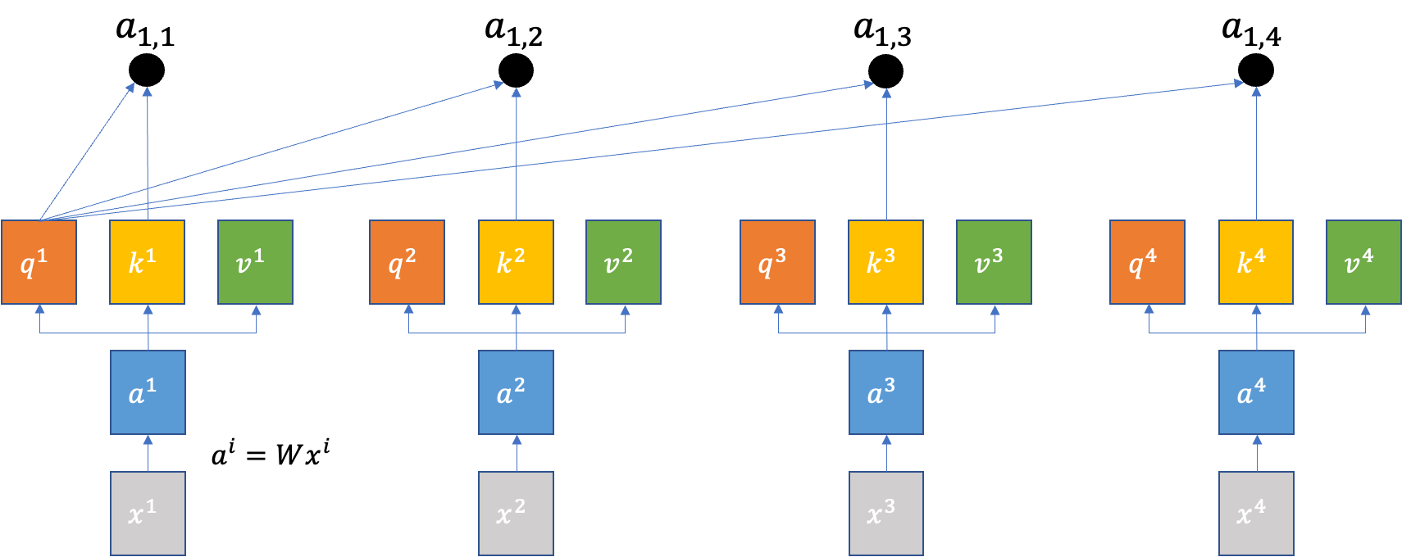

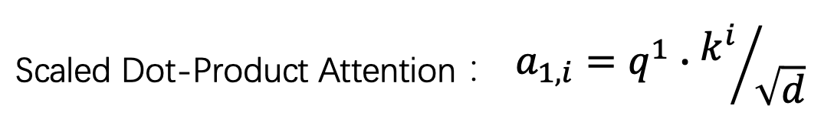

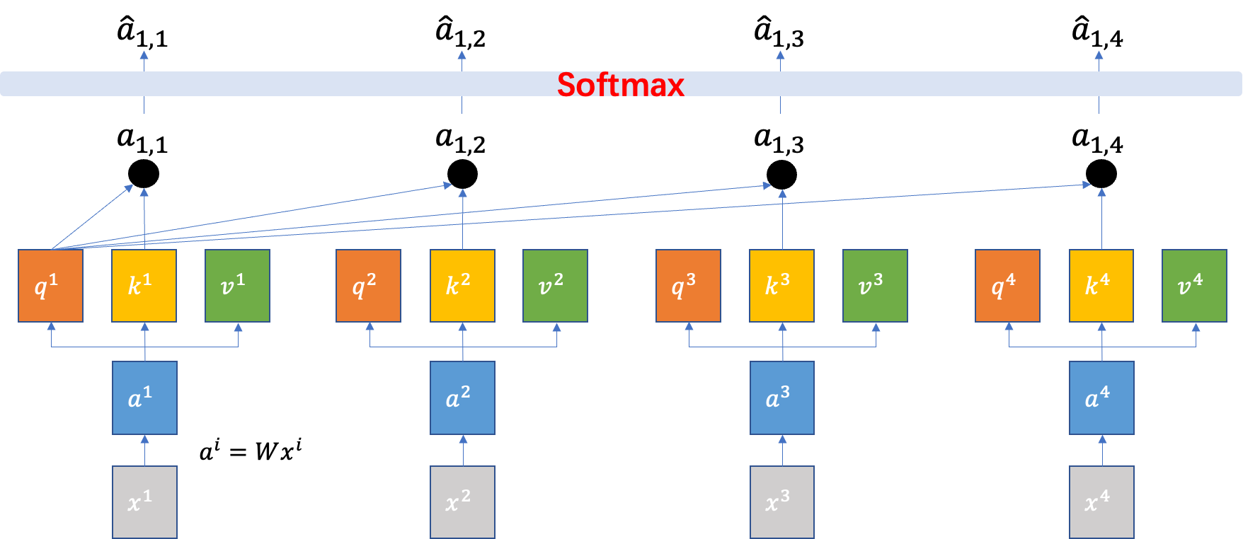

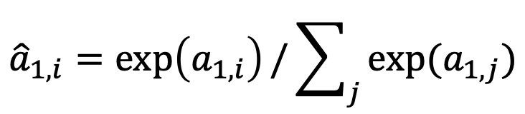

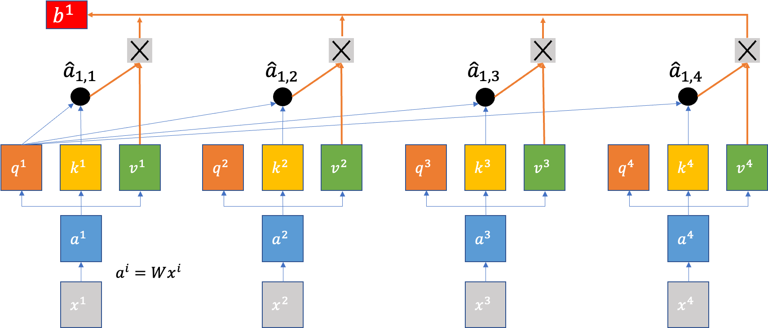

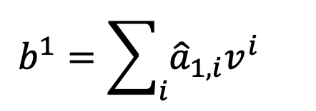

**二、Multi-Headed Attention并行化**

|  |  |
| --- | --- |
|  |  |

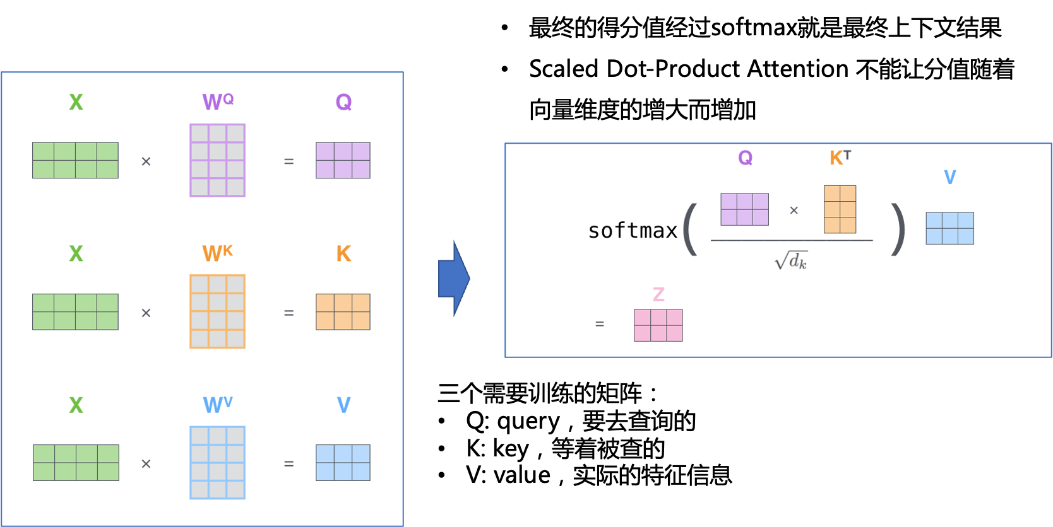

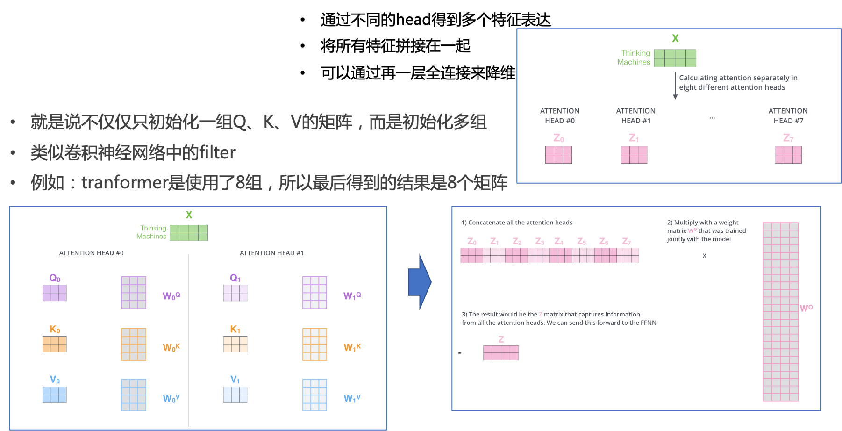

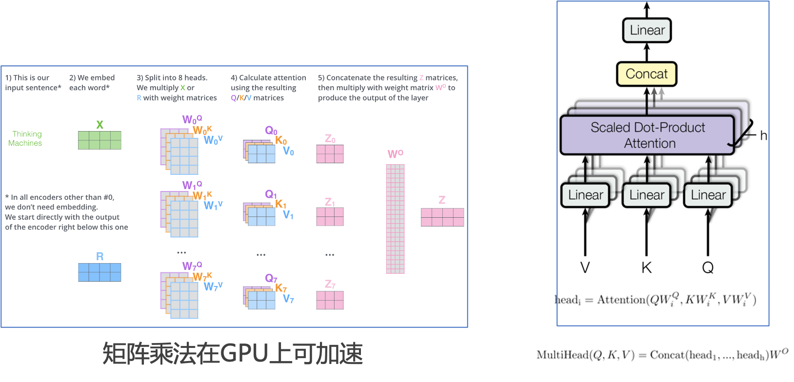

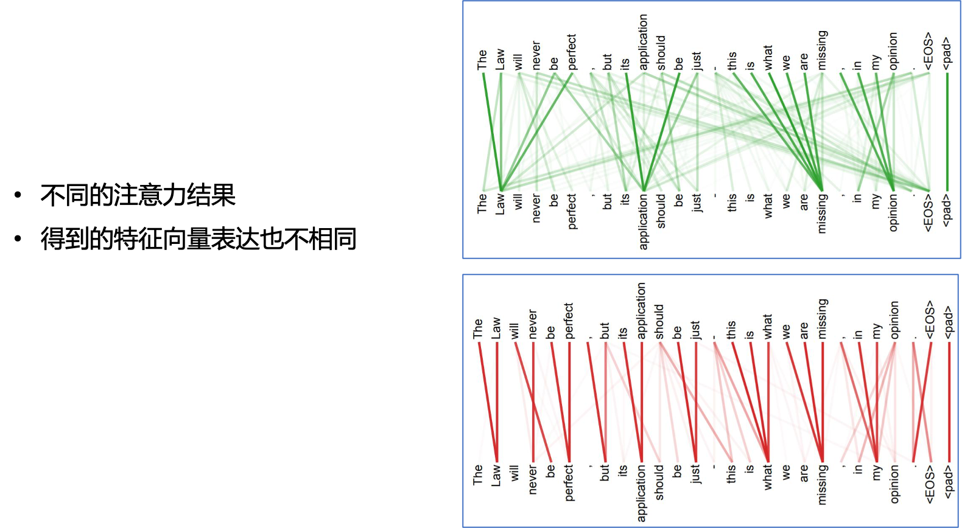

**三、Position Encoding**

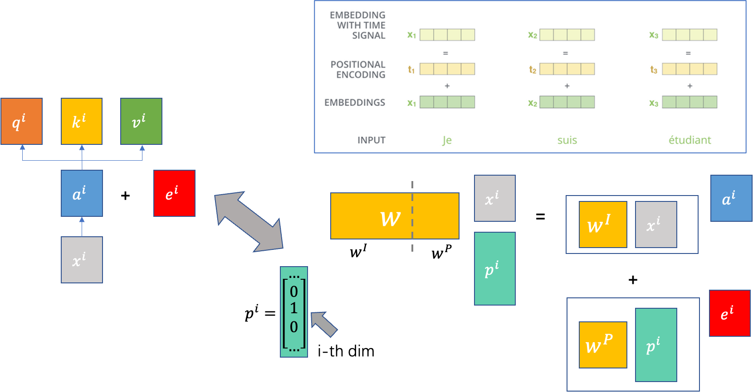

**四、Transformer**

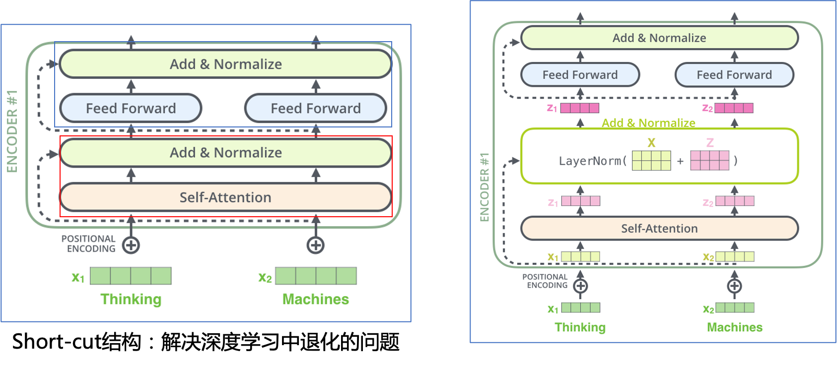

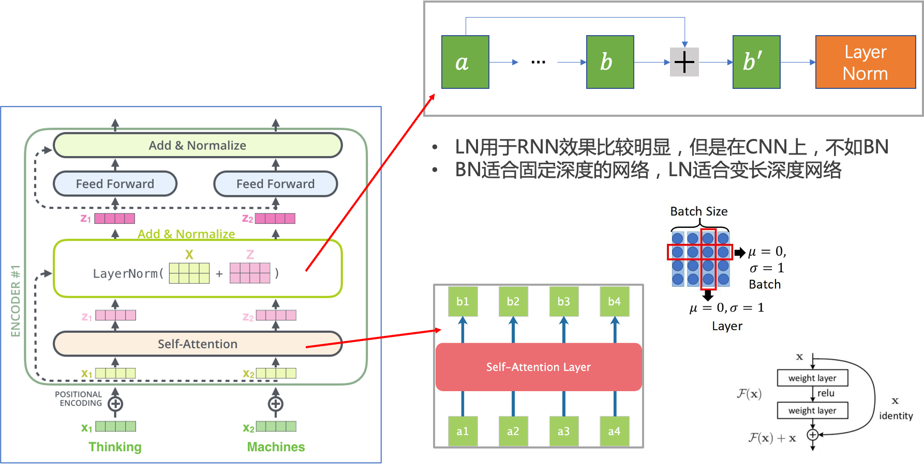

|  |  |
| --- | --- |
|  | Transformer 逐步取代 RNN、CNN 成为最主流的特征抽取器  RNN的问题：   * 难以具备并行计算能力   CNN的问题：   * 单层卷积无法捕获远距离特征 * Dilated CNN容易错失重要特征组合 * 加深CNN参数设置不方便 |
|  | 最终输出结果   * 得出最终预测结果 * 损失函数 cross-entropy |

**五、Bert**

Bidirectional Encoder Representations from Transformers

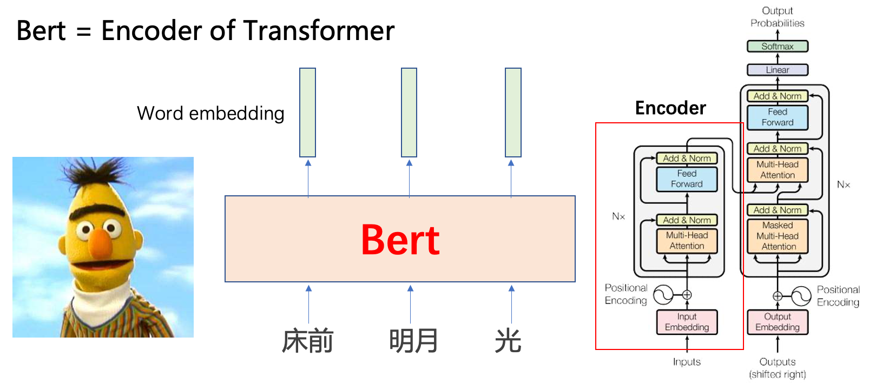

**1、Embeddings**

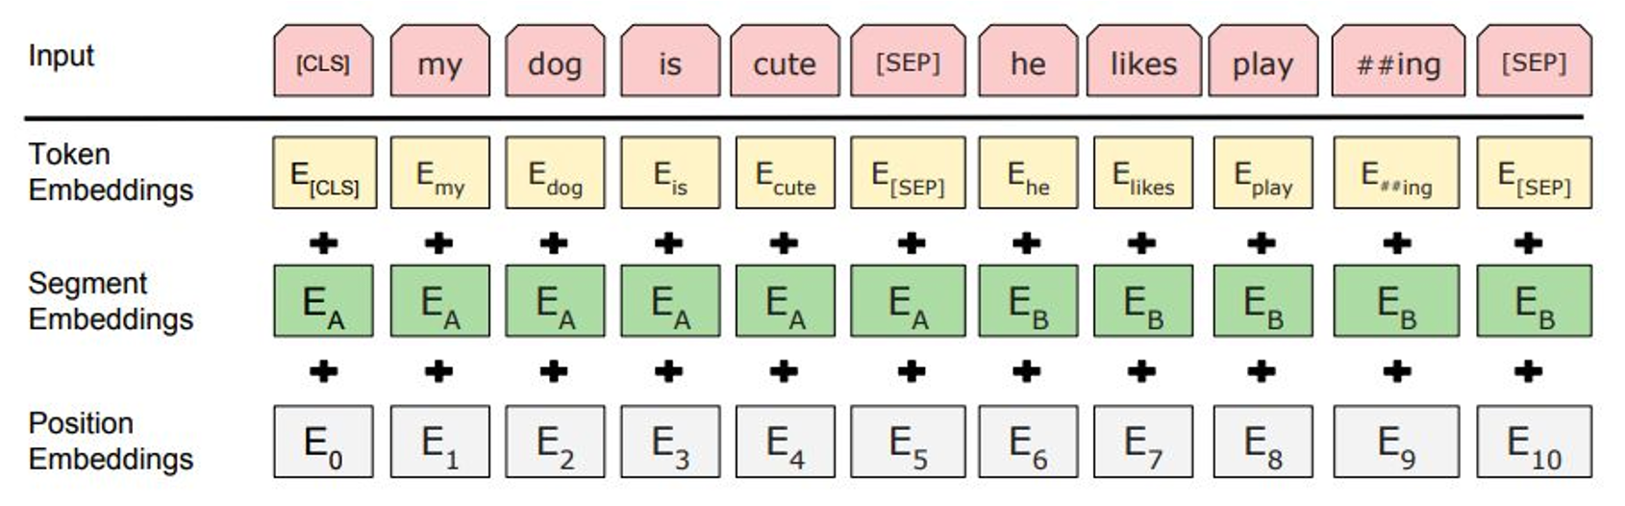

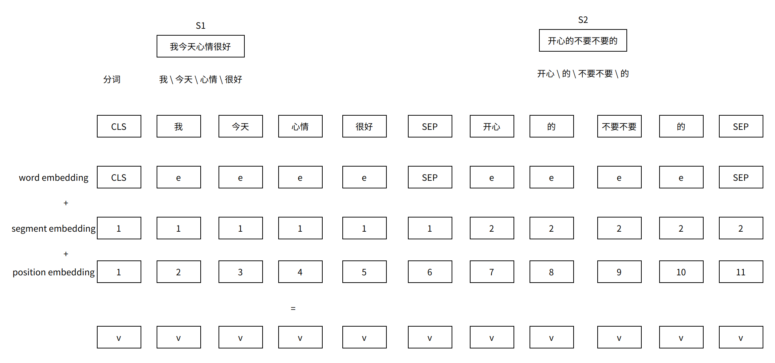

**参考：**

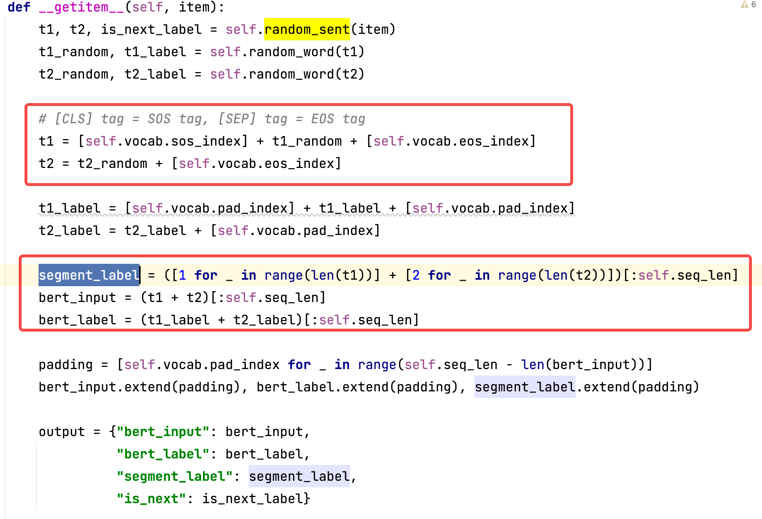

**2、两阶段**

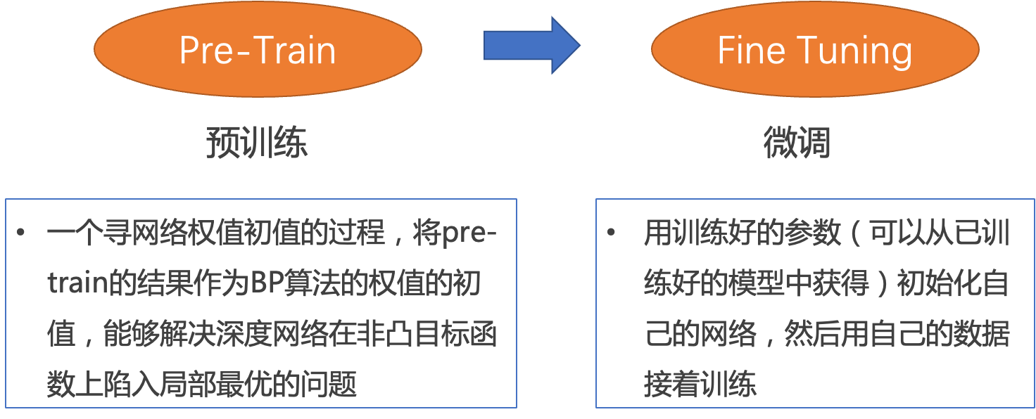

**3、两大任务**

**（1）Mask LM = MLM**

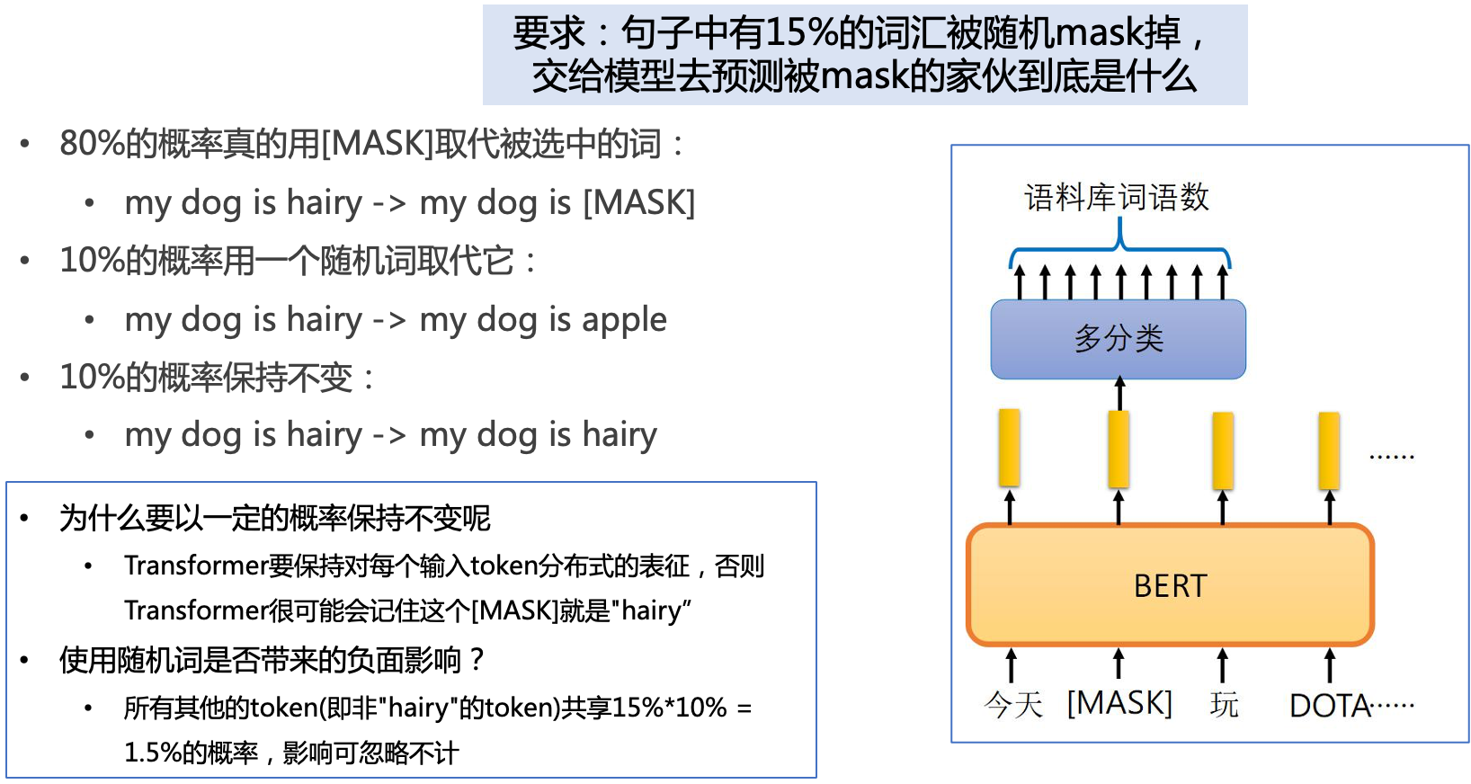

|  |
| --- |
| Python **def** random_word(self, sentence):  tokens = sentence.split()  output_label = []   **for** i, token **in** enumerate(tokens):  prob = random.random()  **if** prob < 0.15:  prob /= 0.15   *# 80% randomly change token to mask token* **if** prob < 0.8:  tokens[i] = self.vocab.mask_index   *# 10% randomly change token to random token* **elif** prob < 0.9:  tokens[i] = random.randrange(len(self.vocab))   *# 10% randomly change token to current token* **else**:  tokens[i] = self.vocab.stoi.get(token, self.vocab.unk_index)   output_label.append(self.vocab.stoi.get(token, self.vocab.unk_index))   **else**:  tokens[i] = self.vocab.stoi.get(token, self.vocab.unk_index)  output_label.append(0)   **return** tokens, output_label |

**（2）Next Seq Predict = NSP**

目标：预测两个句子是否应该连在一起

[seq]:两个句子之间的连接符，[cls]:表示要做分类的向量

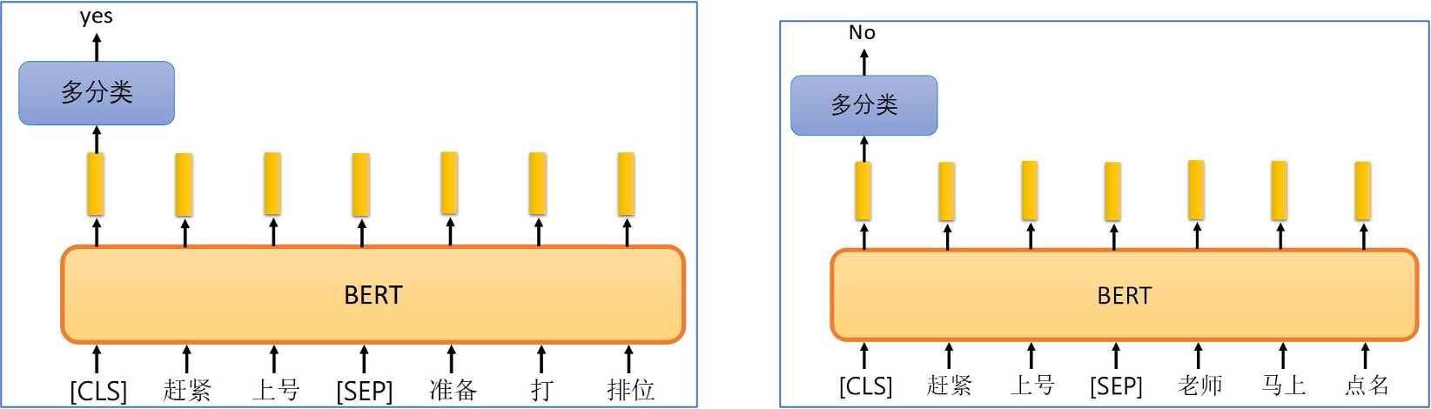

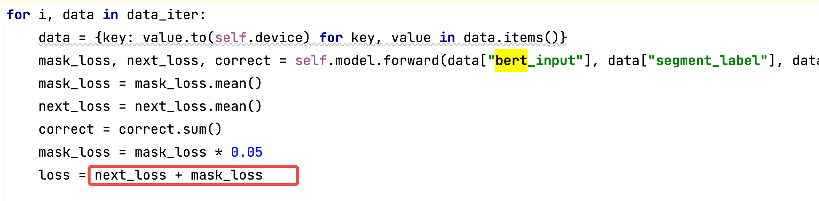

|  |  |
| --- | --- |
|  |  |
| **MLM** | **NSP** |
|  |  |
| **Attention** |  |
|  |  |

|  |
| --- |
| Python  **class** BERT(nn.Module):  *"""*  *BERT model : Bidirectional Encoder Representations from Transformers.*  *"""*  **def** __init__(self, vocab_size, hidden=768, n_layers=12, attn_heads=12, dropout=0.1):  *"""* **:param** *vocab_size: vocab_size of total words* **:param** *hidden: BERT model hidden size* **:param** *n_layers: numbers of Transformer blocks(layers)* **:param** *attn_heads: number of attention heads* **:param** *dropout: dropout rate*  *"""*  super().__init__()  self.hidden = hidden  self.n_layers = n_layers  self.attn_heads = attn_heads   *# paper noted they used 4*hidden_size for ff_network_hidden_size* self.feed_forward_hidden = hidden * 4   *# embedding for BERT, sum of positional, segment, token embeddings* self.embedding = BERTEmbedding(vocab_size=vocab_size, embed_size=hidden)   *# multi-layers transformer blocks, deep network* self.transformer_blocks = nn.ModuleList(  [TransformerBlock(hidden, attn_heads, hidden * 4, dropout) **for** _ **in** range(n_layers)])   **def** forward(self, x, segment_info):  *# attention masking for padded token*  *# torch.ByteTensor([batch_size, 1, seq_len, seq_len)* mask = (x > 0).unsqueeze(1).repeat(1, x.size(1), 1).unsqueeze(1)   *# embedding the indexed sequence to sequence of vectors* x = self.embedding(x, segment_info)   *# running over multiple transformer blocks* **for** transformer **in** self.transformer_blocks:  x = transformer.forward(x, mask)   **return** x |

分类问题：

|  |
| --- |
| Apache **def** random_sent(self, index):  t1, t2 = self.get_corpus_line(index)   *# output_text, label(isNotNext:0, isNext:1)* **if** random.random() > 0.5:  **return** t1, t2, 1  **else**:  **return** t1, self.get_random_line(), 0 |

**（3）Fine Tuning（微调）**

在海量单预料上训练完BERT之后，便可以将其应用到NLP的各个任务中

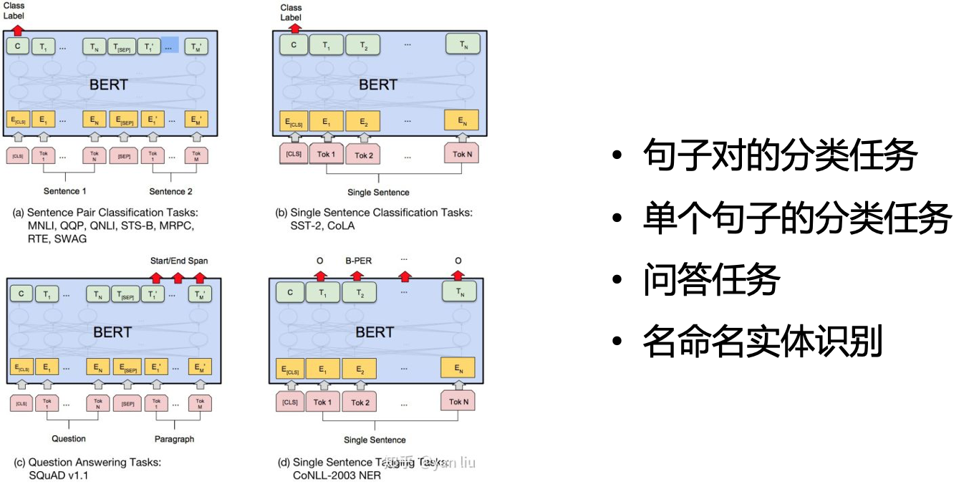

**六、实践**

**[bert.tgz]**

1. **pretrain代码整体架构图**

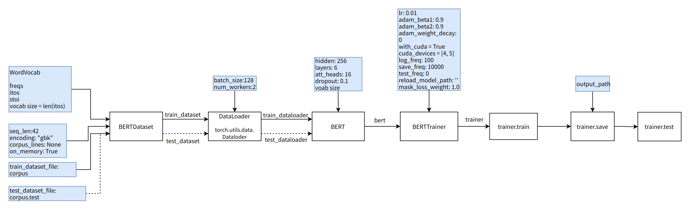

**1.1 BERTDataset**

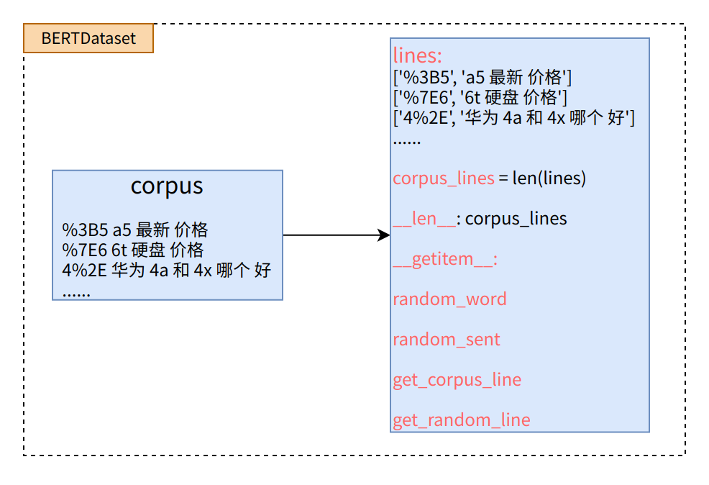

**1.2 BERT模型的构建**

**1.2.1 BERTEmbedding**

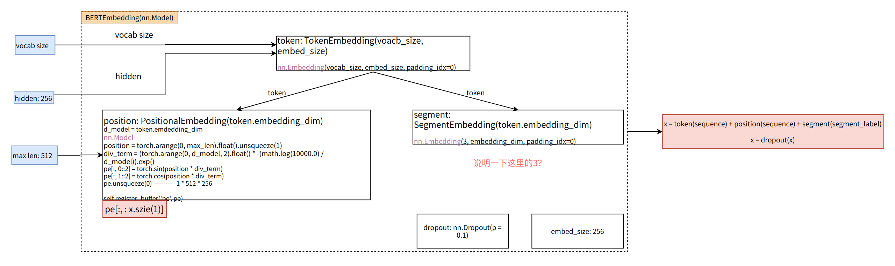

**1.2.2 TransformBlock**

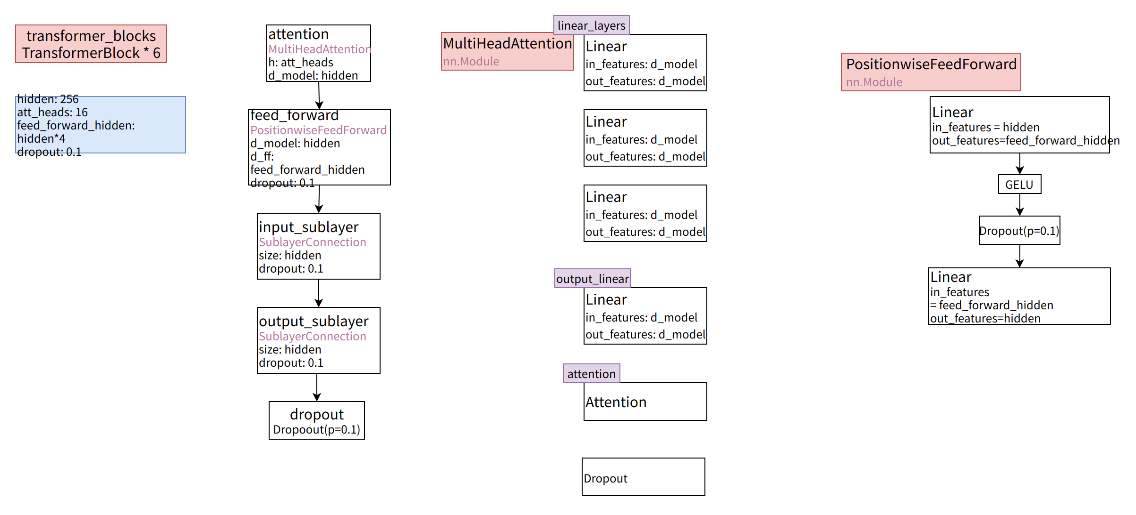

**1.3 BERT模型的训练**

**1.3.1 BERTLM的训练流程**

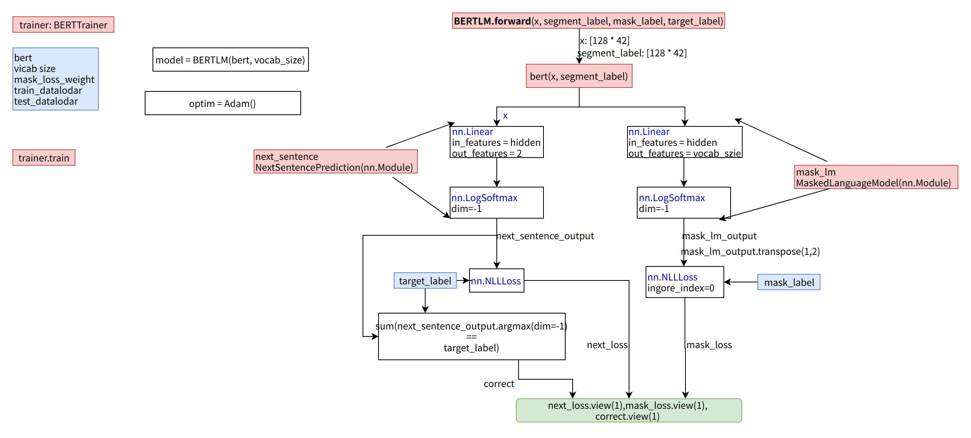

**1.3.2 BERT的训练流程**

